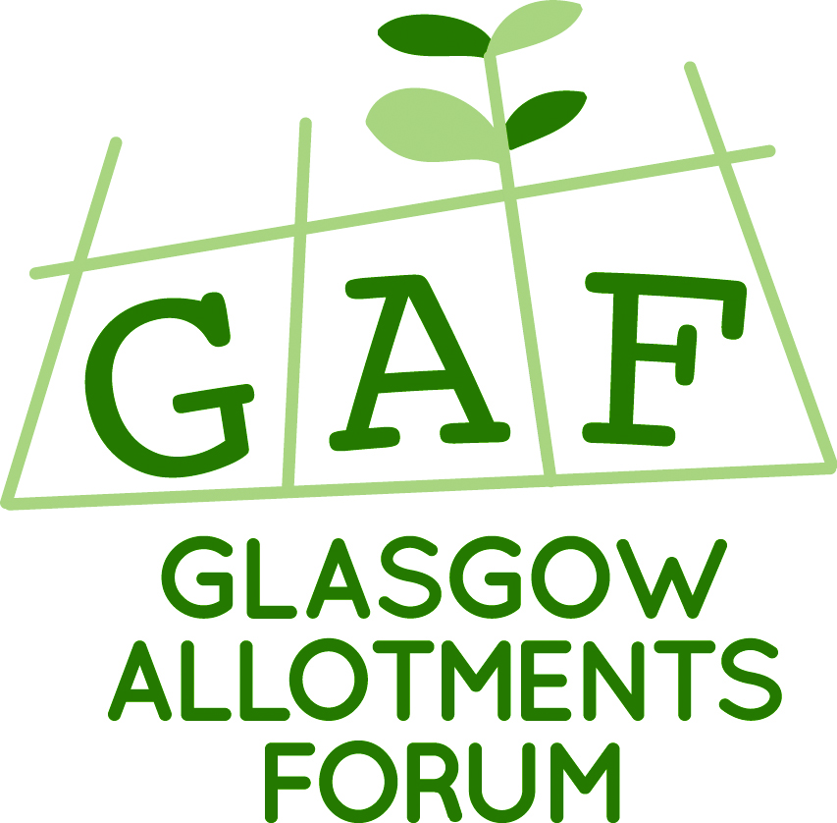

Dear Secretary,

With another growing season underway, we’re all focused on our plots, plants and produce; doing what we love best – growing.
Celebrating our hard work and achievements encourages us all, especially our newest members and so GAF invites your site and plot-holders to participate in the annual New Plot-holder Awards .

The New plot-holder Awards aims to encourage, recognise and reward those individuals who rise to the challenge of a new plot
New plot-holders come to a plot which may or may not be in good condition, with a variety of previous gardening experiences, skills and backgrounds.
Whatever the starting point, the enthusiasm, hard work and commitment demonstrated by a new plot holder is to be commended and encouraged.

Please encourage your new plotholders to enter this competition.
We have tried to widen the criteria based on the feedback from previous entries and would value any thoughts you have too.

To be eligible you will have taken on your plot on or after January 2016.

Please note the closing date for entries is 3rd July 2017.

Judging will take place on Tuesday 11th July 2017.

Fiona McGuire (on behalf of Glasgow Allotments Forum)

glasgownewplotholdersaward@gmail.com

